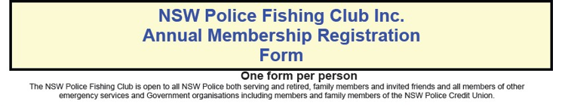

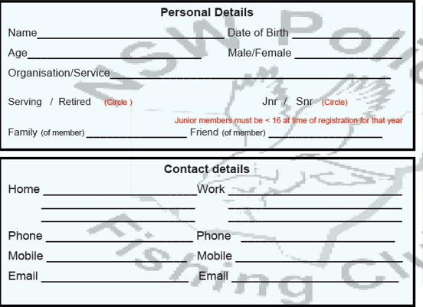
ANNUAL MEMBERSHIP FEES
(payable calendar year)

Adults $15
Adults NSW Police Council of Sport members $5
Children $10
Family $40 (2 adults, 2 children u/16. $5 for each child thereafter)

Become a member of the NSW Police Council of Sport (NSWPCOS) for $1 per week and pay only $5 annually for membership of the Fishing Club. Receive great benefits and savings on entry to Police Games or nominated angling events. For more details; visit nswpolicesport.com.au
Email forms to Peter O’Reilly at orei1pet@police.nsw.gov.au OR plumpypete@gmail.com or contact via email to obtain mailing address
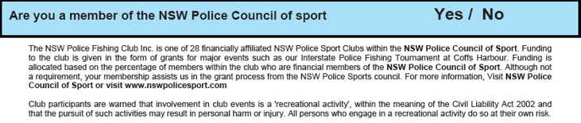

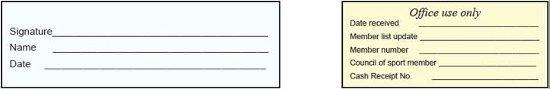
* Please tick appropriate payment method
- Direct deposit. NSW Police Fishing Club, Police Credit Union account 234215 S1. BSB 815-000.
Direct deposit - include your name in the details of that transaction for identification of payment to this form. Email form to orei1pet@police.nsw.gov.au.

- Cash payment, direct in person only with order form.

